- Write a query that lists each order number followed by the name of the customer who made the order.
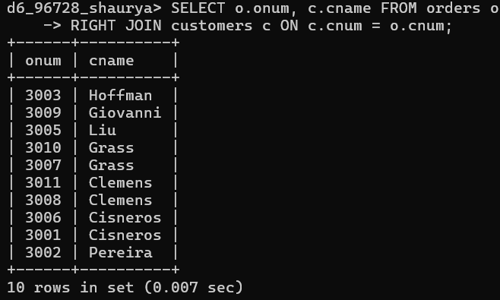

- Write a query that gives the names of both the salesperson and the customer for each order along with the order number.

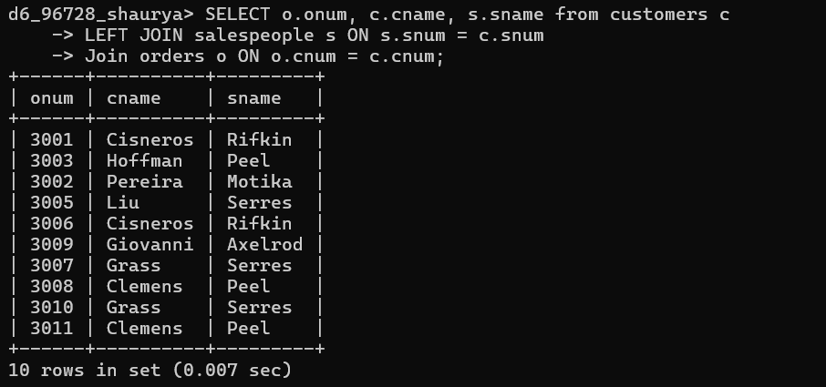

- Write a query that produces all customers serviced by salespeople with a commission above 12%. Display the customer’s name, the salesperson’s name, and the salesperson’s rate of commission.

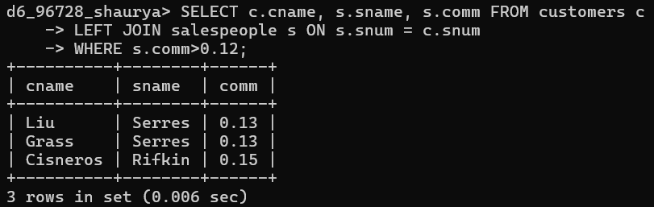

- Write a query that calculates the commission earned by each salesperson for orders placed by customers with a rating above 100.

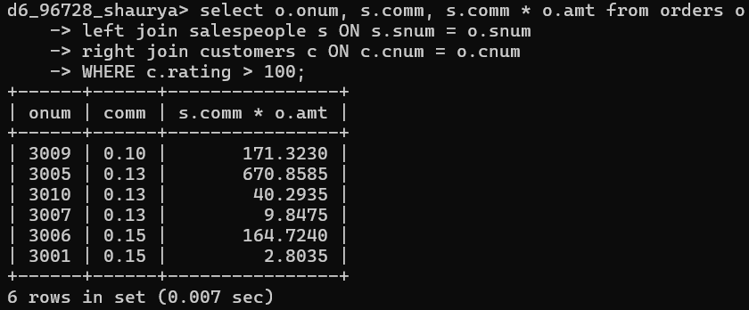

- Write a query that produces all pairs of salespeople who are living in the same city. Exclude combinations of salespeople with themselves as well as duplicate rows with the order reversed.

This is correct:
select s.sname, o.sname, s.city, o.city from salespeople s
JOIN salespeople o ON s.snum = o.snum where s.city = o.city;

Select a.sname, b.sname from salespeople a, salespeople b where a.sname > b.sname and a.city = b.city;

This is wrong:
Select s.sname, s.city, o.sname, o.city from salespeople s
inner join salespeople o ON s.snum = o.snum
where s.city = o.city;
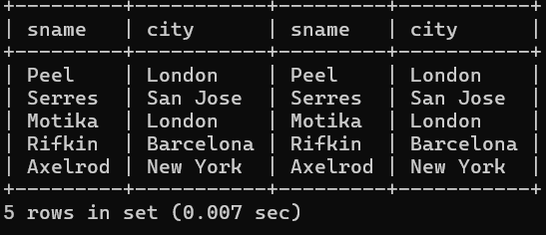

In both of your attempts, I joined the table on the same unique ID (snum or sname). This essentially "match every person with themselves," which is why no pairs of different people.
To get all pairs in the same city, you need to join based on the city column instead of the ID.
s.sname > o.sname: It prevents duplicates like (Peel, Motika) and (Motika, Peel) because only one of those names will be alphabetically "smaller" than the other
